Yoobee College of Creative Innovation - Christchurch Campus

Diploma in Software Development 2202-Online-DSD

**Finlay Macbeth 270177904@yoobeestudent.ac.nz**

**CS104 - UX Principles II**

**Assignment #2**

**Game / App UX Dev**

# Colours

**Background: #1D4B87**

**Main Heading: #C8C8DB**

**Secondary Heading: #B0ECFF**

**Content Heading Main: #2E7CDD**

**Content Heading Secondary: #C8C8DB**

**Body text 1: #C8C8DB**

**Body text 2: #B0ECFF**

**Body text 3: #FFFFFF**

**Special / text 1: #A10000**

**Special / text 2: #FFFFFF**

**Special / text 3: #B0ECFF**

**Module Colour Main: #172344**

**Module Colour 2nd: #** **B0ECFF**

# Icons To be Used

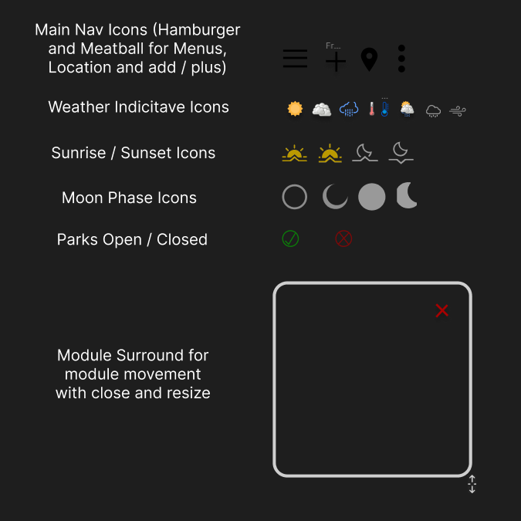

**Taken from Figma, as it was easier to plan and arrange in that software.**

**All SVG Icons were either built in Figma, or sourced from open source Icon Libraries Online, predominantly** [**https://www.svgrepo.com/**](https://www.svgrepo.com/)

# Font Styles:

**Main Heading: Inter, Semi Bold, 20 Pt, Drop Shadow**

**Secondary Heading: Inter, Regular, 12Pt, Drop Shadow**

**Content Heading Main: Inter, Regular, 15Pt, Drop Shadow**

**Content Heading Secondary: Inter, Regular, 16Pt, Drop Shadow**

**Body text 1: Inter, Regular, 10Pt, Drop Shadow**

**Body text 2: Inter, Light Italic, 12pt, Drop Shadow**

**Body text 3: Inter, Regular, 12pt, Drop Shadow**

**Special / text 1: Inter, Medium, 12pr, Drop Shadow**

**Special / text 2: Inter, Italic, 12pt, Drop Shadow**

**Special / text 3: Inter, Light Italic, 20pt, Drop Shadow**

**Android Sketch / Tablet Surface Sketch**

**The Intent with the sketch designs was to achieve the highest simplicity to suit our users who spend as short as 30 seconds browsing and need to find a few pieces of information fast. The Phone design has a hamburger menu for the main pages, a search bar (which We went away from in the prototype due to space cluster) and a search / location selection function.**

**Further down the page youll find a filter / meatball menu for more information / more specific information from within the page, followed by the page content split into modules which can be closed and re arranged.**

**The tablet design shows more pages and has a smaller menu inside the hamburger menu, has a large search bar, as well as the search and location selection. The rest of the page content is the same except a different size and proportion to allow for pleasurable browsing on a tablet.**

**Android Lofi / Tablet Surface Lofi**

**Due to size it was not practical to show all of the tablet pages in the report**

**Android Hi Fi Prototype**

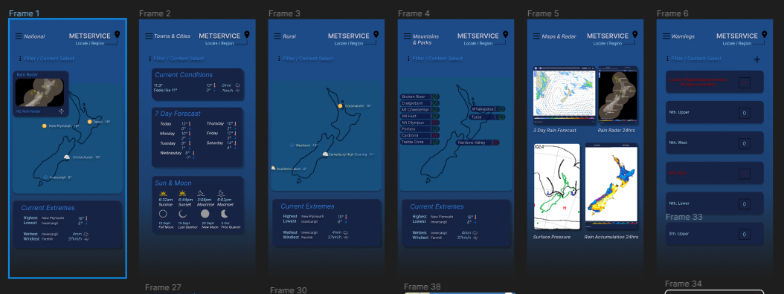

**Shown above is the set of pages from the HiFi Prototype – Sans Overlays, these can be viewed in the online project, found in the readme file. I chose to portray the final app in mobile as the bulk of our users from research show they are viewing less than 30 seconds per session, mostly from home, so are likely to be using a cellphone most of the time. The colour scheme chosen is simple, our users preferred dark mode, but we wanted to circumvent this and provide a light coloured positive tone to the app, so we chose to set our overlays in a dark colour, sat on a light palette to increase mood / experience. As per our research these modules can be selected and moved around or removed. (only a mock up in the figma design, just for show) for user convenience. As you can see from the colour palette and font styles above, we utilised about 6 font styles, and 6 colours, and did our best to reuse these, creating a lovely scheme, with less readjusting necessary throughout the design.**

**For the warnings page, current warnings are shown red, with a number of warnings shown.**